Lesson 1 – First App: Scrolling Name Badge

1. Go to <https://makecode.microbit.org/>
2. 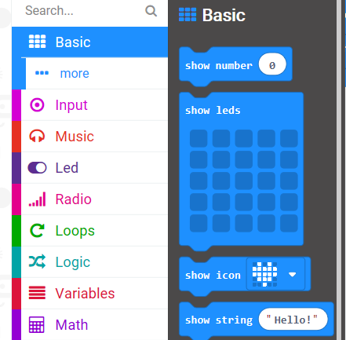Click on **Basic** and drag the ***show string*** **block**
3. Change the test **string** to your name by double clicking

1. Check it works in the simulator
2. Give the file a name
3. Make sure your **micro:bit** is plugged into a USB port



1. **Download** and **flash**



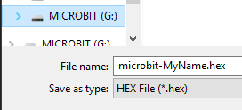

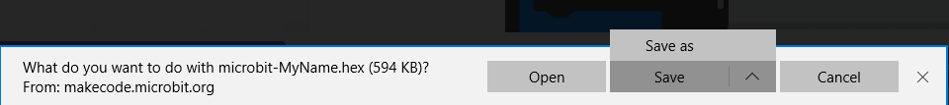

1. The program will now run on the micro:bit